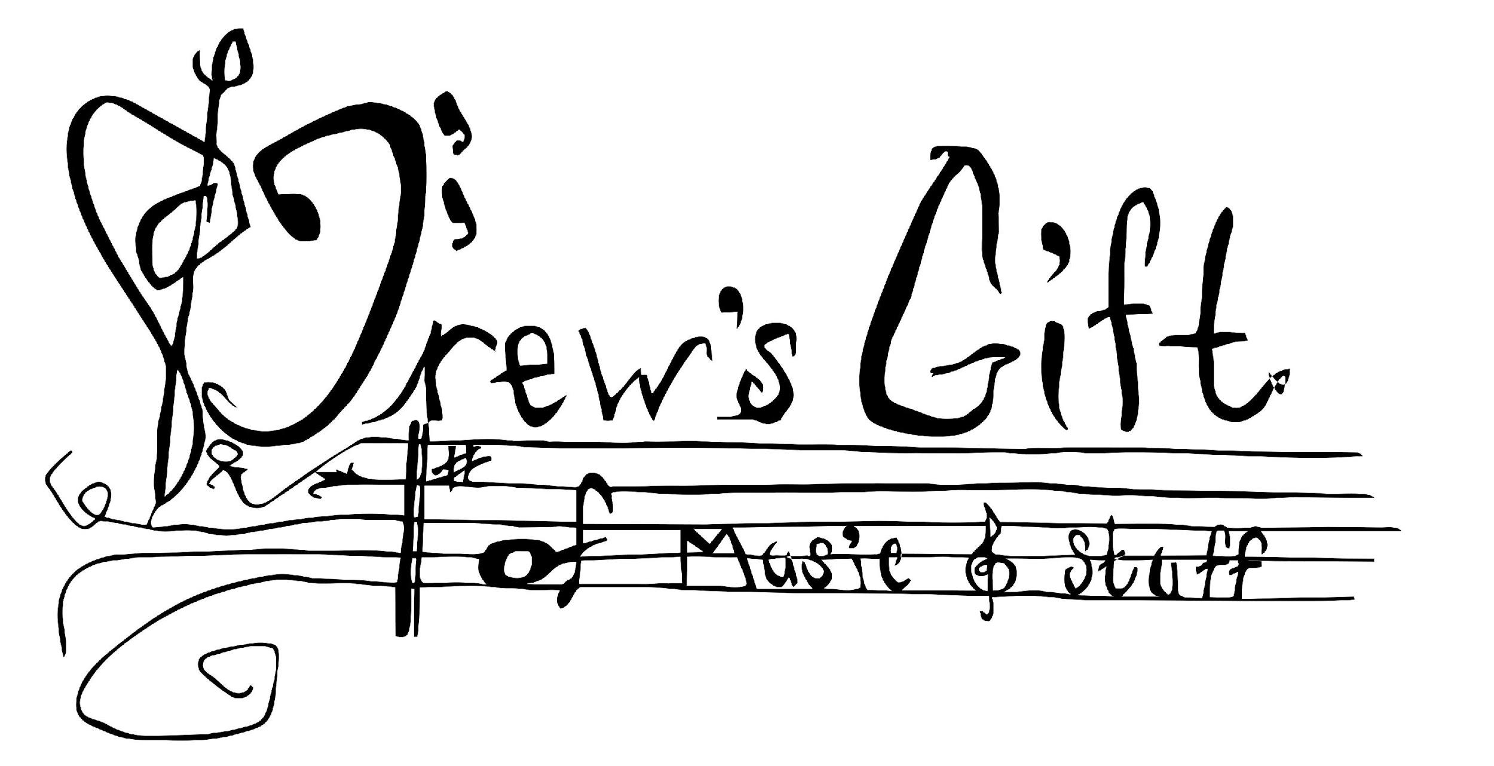
DREW’S GIFT OF MUSIC

Instrument Request Form
Email: drewsgiftofmusic@gmail.com

Director Fill Out Box Below
School: _________________________________Address: _____________________________________________________________

Phone Number: ____________ Band Director: _______________ Director’s Phone #:_____________ Program Start Date: ________

Director’s Email: ______________________________________________ Instrument Requested: _____________________________

First Name: __________________________ Middle: ______ Last:________________________________________ Grade:________

Home Phone: _____________________________ Date of Birth: _______________ Gender (M/F): ______ Current Age: __________

Address: ________________________________________________City: ____________________________Zip Code: ______________

Parent or Guardian (1):_____________________________Relation to Student: _______________________ Lives with Student? Y/N

Employer:___________________________ Work Number: _______________________ Cell Number: ________________________

Parent or Guardian (2):_____________________________Relation to Student: _______________________ Lives with Student? Y/N

Employer:___________________________ Work Number: _______________________ Cell Number: ________________________

Preferred email: ______________________________________________

The following information is needed for your instrument request. Our decision is not solely based on income. The answers you provide are completely confidential.

Does your child receive/qualify for the FREE LUNCH PROGRAM? Yes / No
Does your child receive/qualify for the REDUCED LUNCH PROGRAM? Yes / No
Does your family receive/qualify for WIC assistance? Yes / No
Does your family receive/qualify for DISABILITY/ SSI/ SSA Benefits? Yes / No
Does your family receive/qualify for TANF/Cash Benefits? Yes / No
Does your family receive/qualify for FOOD STAMPS? Yes / No
Does your family receive/qualify for MEDICAID/HOOSIER HEALTHWISE? Yes / No
Does your family receive/qualify for SOCIAL SECURITY/SURVIVOR BENEFITS? Yes / No

How many adults live in your home? _______ How many children live in your home? _______
Estimated annual income ____________________ (This is necessary and confidential).
Other sources of income _____________________

If you answered no to all of the above please tell us your circumstances for the instrument request:___________________________

__________________________________________________________________________________________________________

Drew’s Gift of Music reserves the right to approve or revoke this agreement at any time.

Signed: ____________________________________________________________ Date: __________________________________
Legal Guardian Signature

Parent or guardian signature

